Olusegun Afolabi
EECE 412
Professor Wenjie

Lab 11
Introduction
In this lab we extend the Lab 10 “Pong Starter” so that the single paddle can be moved not only up and down but also left and right. By decoding two additional push-buttons on the FPGA board, we transform what was a strictly vertical control scheme into a true four-way navigation interface. This enhancement deepens our understanding of VHDL state updates, boundary enforcement, and unified input handling, while delivering a more engaging and dynamic Pong experience.
Conceptual Design
- Unified Button Vector
All four directional controls (UP, DOWN, LEFT, RIGHT) are carried on a single multi-bit input. At each video‐frame boundary, exactly one of the four directions may be asserted, simplifying control logic into a single, clocked decision block.
- Dynamic Position Registers
Instead of fixed constants, the paddle’s horizontal (X) and vertical (Y) positions are maintained in two registers. On each frame tick, one of these registers is incremented or decremented according to which button is pressed, then clamped to the extents of the playfield.
- Single, Synchronous Process
A single clocked process examines the four-bit button vector and adjusts the X or Y register by one pixel per frame. By grouping all movement logic in one place, we ensure consistent timing and eliminate race conditions between horizontal and vertical updates.
- Screen-Edge Enforcement
Before updating, each register value is checked against its respective minimum and maximum limits. This guarantees the paddle can never travel off-screen in any direction, preserving correct gameplay boundaries.

Questions:
- 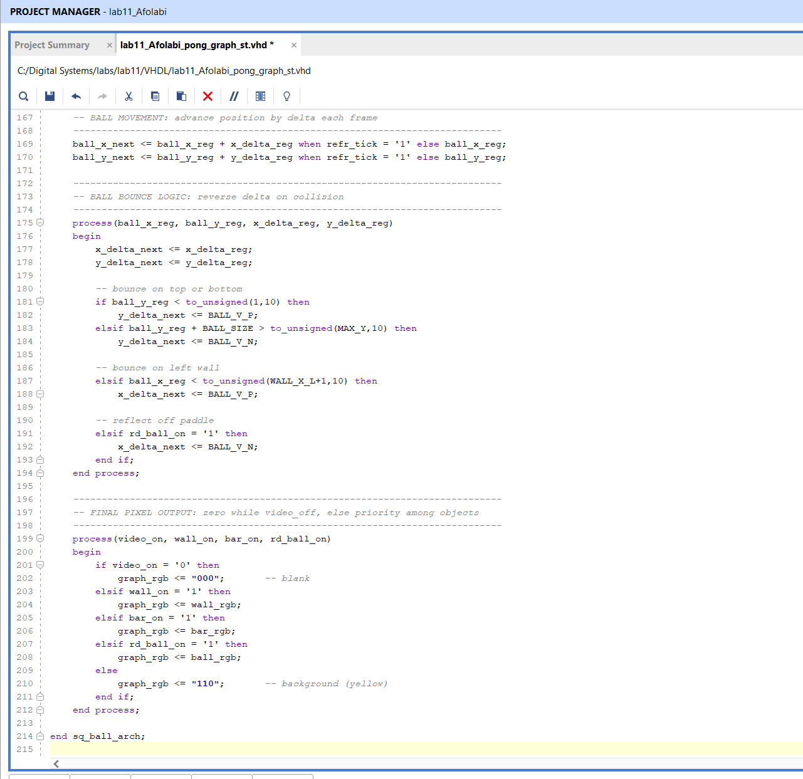
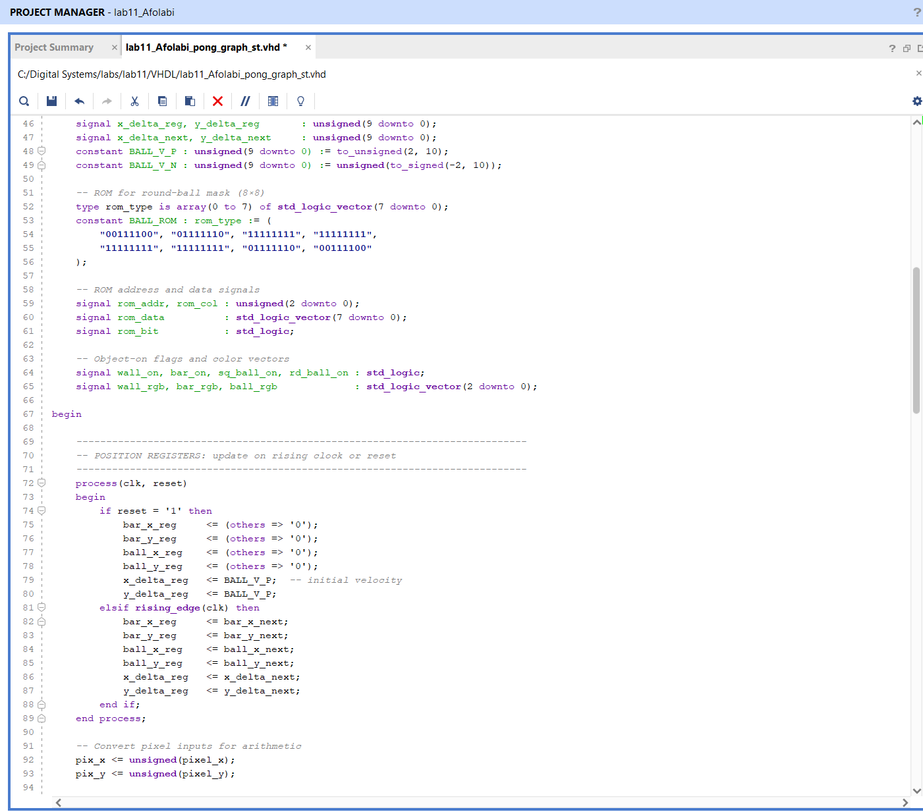
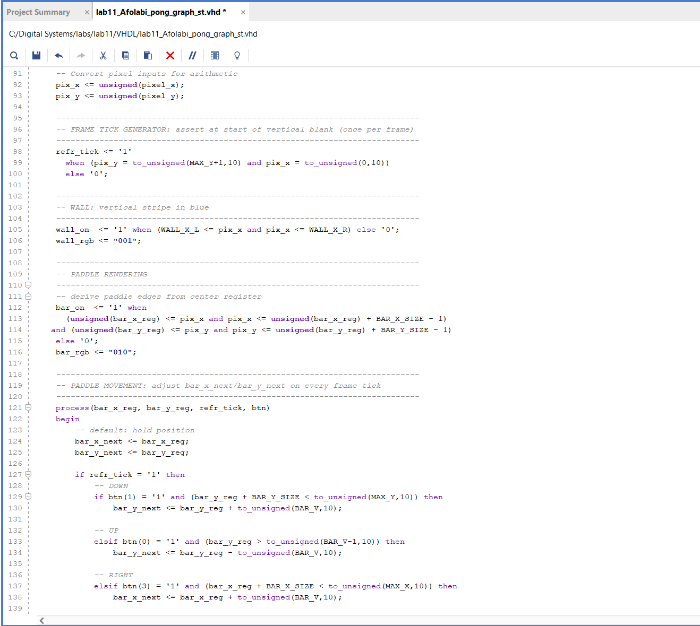
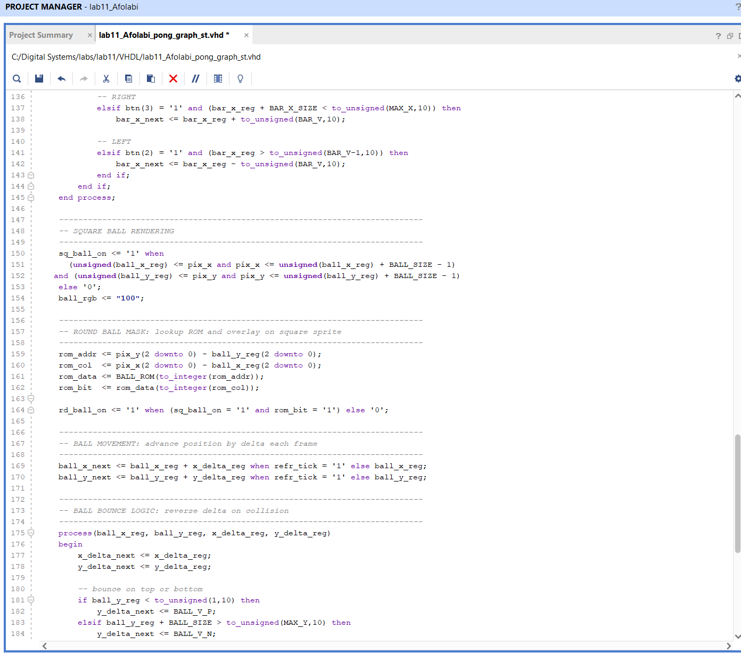
- Buttons Movement Process:
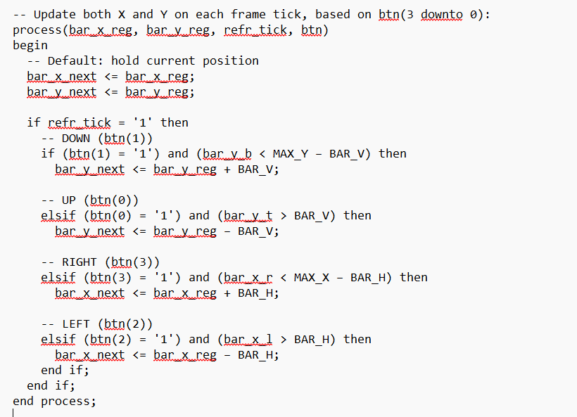

Registers for horizontal boundaries
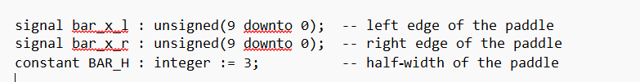

Expanded button vector
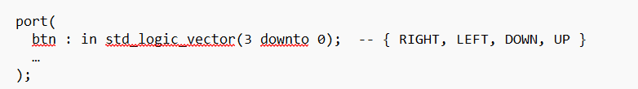

- 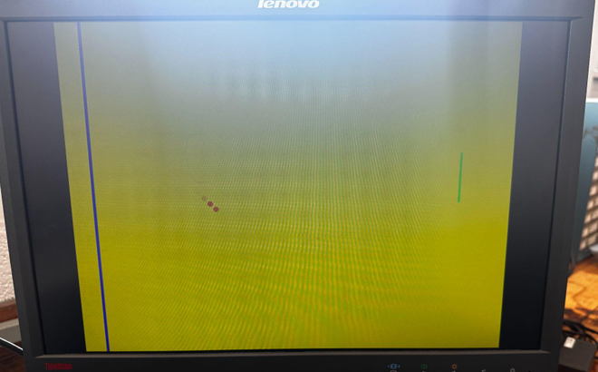
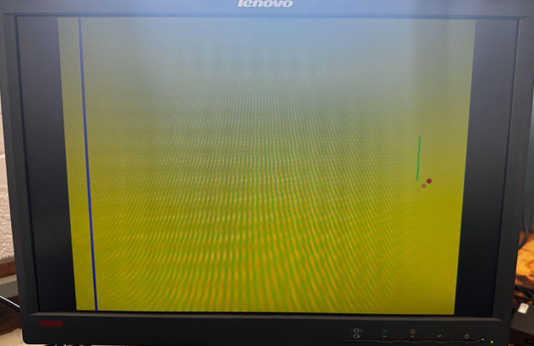
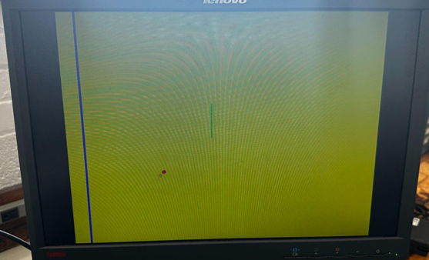
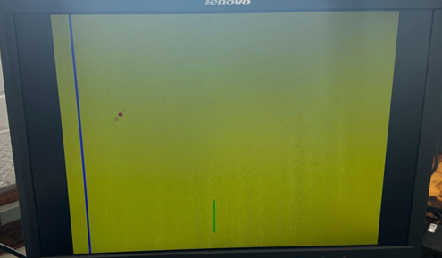

Conclusion
In this lab, we successfully extended our Lab 10 Pong implementation by adding full four-direction paddle control. By refactoring the original VHDL process to handle LEFT and RIGHT inputs, replacing fixed horizontal constants with dynamic boundary registers, and expanding the btn vector in both the graphics and top-level modules, we enabled smooth, frame-synchronous horizontal motion alongside the existing vertical movement. Updating the .xdc constraints ensured that all four push-buttons correctly map to the new control signals. The final design delivers a significantly richer playing experience—players can now maneuver the paddle anywhere on the screen, making the game both more challenging and more engaging.

